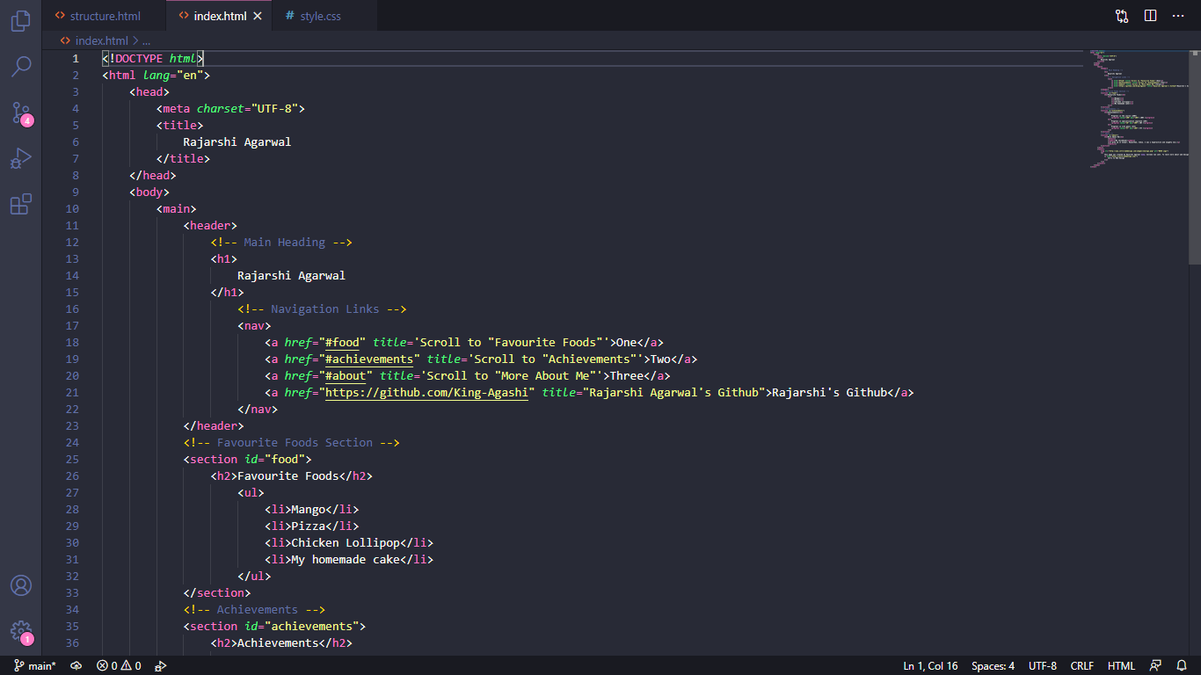

* Document Type declaration
* Language selection
* **In head:**
* Meta data - Character set selection
* Title
* **In Body:**
* Main
* Header Tag
* H1 heading (main heading – highest order semantics)
* Nav tag
* 4 anchors
* **Section 1 – Favorite Food**
* Id defined and linked to nav
* H2 heading (second order heading semantics)
* Unordered list – ul
* 4 list items - li
* **Section 2 – Achievements**
* Id defined and linked to nav
* H2 heading (second order heading semantics)

(Continued in 2nd screenshot)

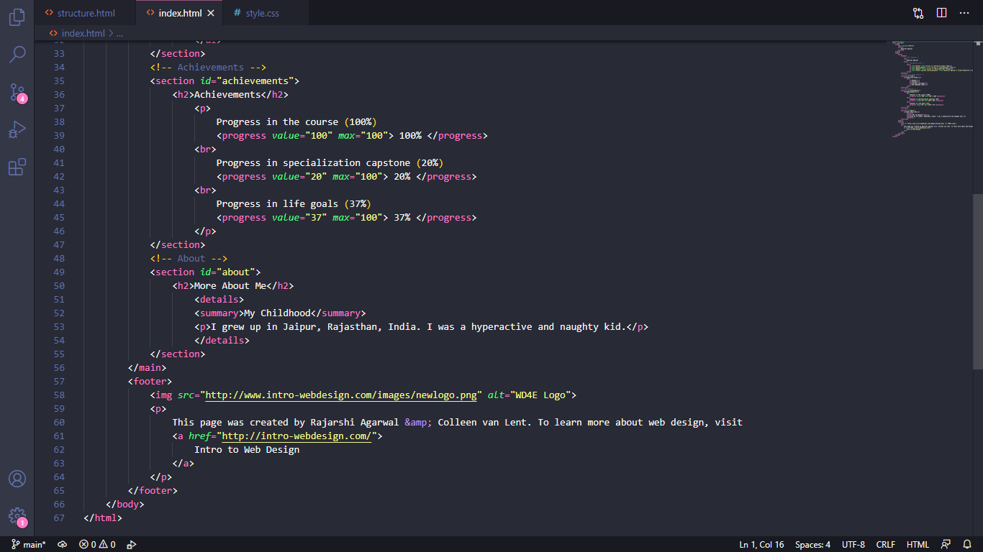

* **Section 2 – Achievements**
* Id defined and linked to nav
* H2 heading (second order heading semantics)
* 3 Progress Bars
* **Section 3 – More about me**
* Id defined and linked to nav
* H2 heading (second order heading semantics)
* Details
* Summary
* Paragraph
* **Footer**
* Image with alt
* Paragraph
* Link

**Resulting Page**

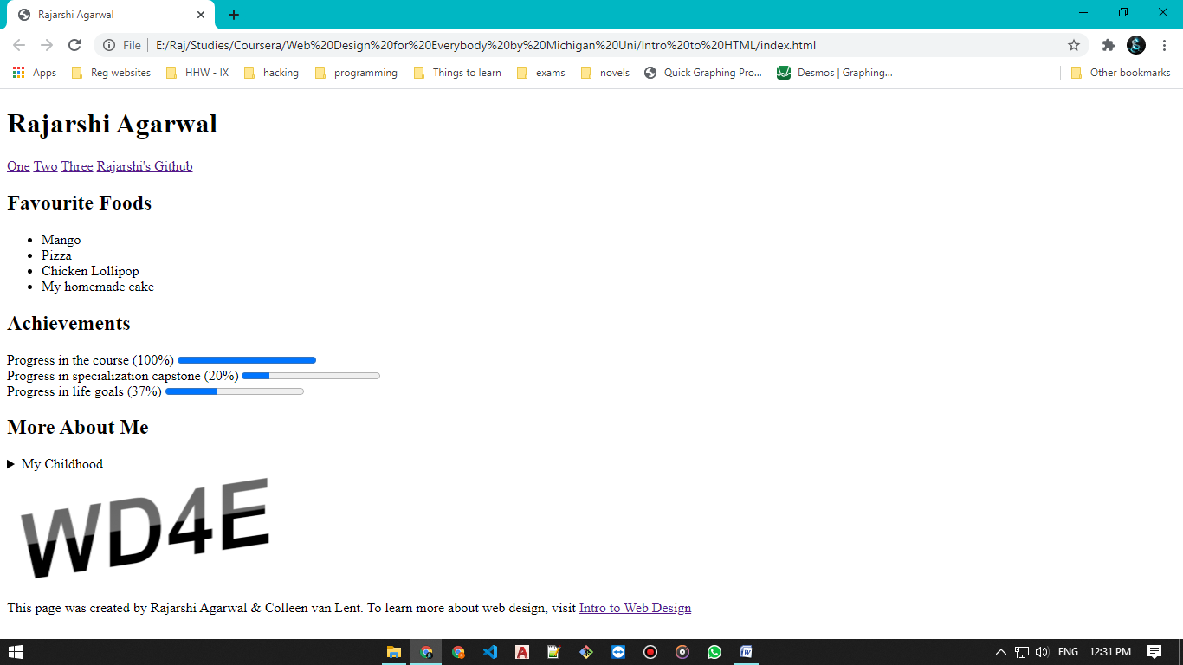

I am providing the HTML file and also hosting the website on the following link:

<https://coursera-html5-final-project.netlify.app/>

Github repository: <https://github.com/King-Agashi/coursera_html5_final_project>